Chapter 6, Problem 57.

Determine the L_{eq} that can be used to represent the inductive network of Fig. 6.79 at the terminals.

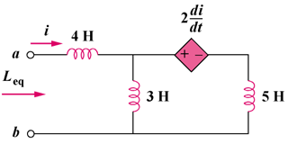

Figure 6.79
For Prob. 6.57.

